Human evolution

Assessment Statements
- Know the recent most close relatives to Homo sapiens
- Explain the Out of Africa hypothesis
- Draw a phylogenetic tree of hominins

Phylogenetic trees
The exact relationships are unclear, also because only a few pieces of bone are available from many hominins. Whether these belong to other species or are variations of one species is interpreted differently. DNA from extinct hominins is only available in a few exceptions, such as Neanderthals.

A possible tree of hominins | “Our” phylogenetic tree
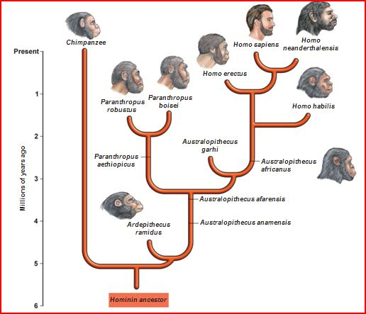 | 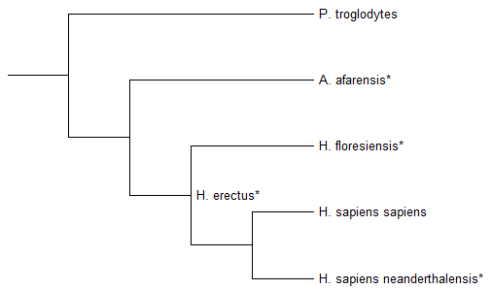* = extinct

Out of Africa
Read the text and fill in the gaps. In the map, show with arrows the journeys of the different hominins.
First humans appeared in central Africa. A million years ago a group of Homo erectus crossed the Red Sea and inhabited Europe and Asia. In Europe and Middle East, a new kind of man evolved, the
Homo neaderthalensis.
At the same time Homo sapiens sapiens evolved in Africa. Out of this population, a rather small group wandered again via the Red Sea towards Europe and Asia. This happened around 60’000 years ago. However, this hominin also colonized America and Australia.
In Europe, the hominins from the first and the second Out of Africa journey met and lived as neighbors for many thousand years until Homo neaderthalensis vanished 30’000 years ago. However, a small part of its genome survived in our chromosomes. All recent humans belong to the same species, sharing more than 98% of their DNA.
Nowadays (Jan. 2025), there are 8.2 billion (8’200’846’000) humans. Until the end of the Middle Ages, the total population was at 200’000’000 or lower and only increased dramatically during modern history. However, there was a time around 70’000 years ago when there lived only around 3000 people! Probably this was a consequence of the Toba supervolcano eruption in Sumatra. Therefore, humans went through a genetic bottleneck event. This explains why humans are so similar, compared to the diversity within most animal species.
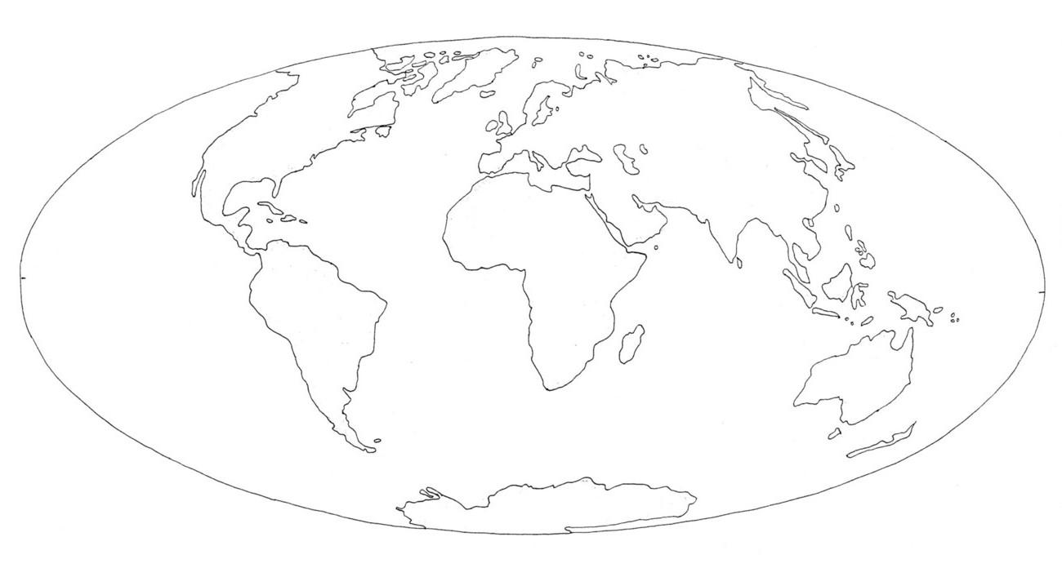

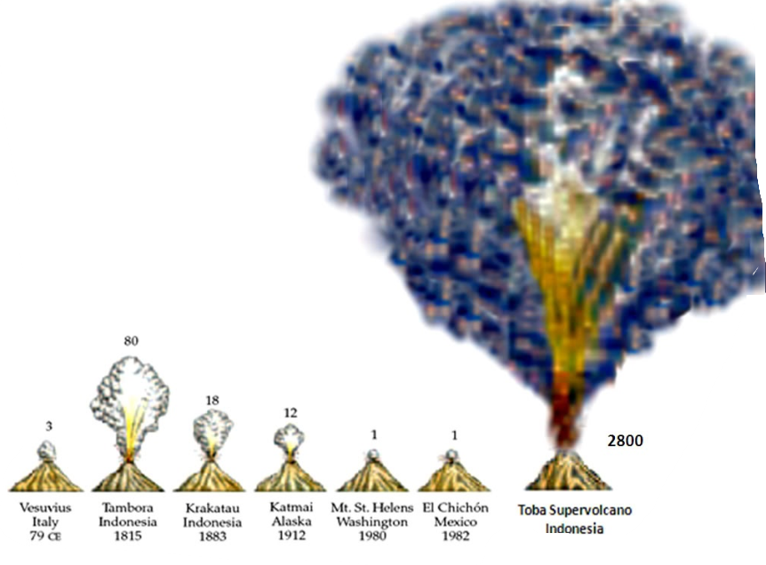
Toba supervolcano
The Toba volcanic eruption was of incredible size. You get an impression by comparing the amount of exposed dust and ashes in km³ (numbers in the diagram) with other huge volcanoes. The Tambora eruption of 1815 led to the Year Without a Summer, darkening the sky that much. However, the Toba eruption covered entire Asia and beyond below 15 cm of dust.

Hominin portraits
 | where they lived | when the lived | new skills | interesting facts
Australopithecus afarensis
Homo habilis
H. erectus
H. sapiens sapiens
H. sapiens neanderthalensis

Used Tools and References
- Roberts, A. (2012). Die Anfänge der Menschheit. Dorling Kindersley Verlag GmbH.
- blendspace.com
- http://www.waldorf-ideen-pool.de/index.php?aid=157
CC BY 4.0 DEED for contents created by Daniel Margadant
For other sources (e.g., figures) please consider © of corresponding reference

